

USEFUL JAPANESE DICTIONARY FOR VIETNAMESE

DETAIL DESIGN DOCUMENT

Class Design

**Project Code: UJD_VN**

**Document Code: UJD_VN_Class Design_v1.1_EN**

**Ha Noi, 05/08/2014**

Record of change

*A - Added M - Modified D – Deleted

|  |  |  |  |  |
| --- | --- | --- | --- | --- |
| **Effective Date** | **Changed Items** | **A* M, D** | **Change Description** | **New Version** |
| 26/06/2014 | Add new | A |  | v1.0 |
| 05/08/2014 | Modify Package | M |  | v1.1 |
|  |  |  |  |  |
|  |  |  |  |  |
|  |  |  |  |  |
|  |  |  |  |  |
|  |  |  |  |  |
|  |  |  |  |  |
|  |  |  |  |  |
|  |  |  |  |  |
|  |  |  |  |  |
|  |  |  |  |  |

SIGNATURE PAGE

**ORIGINATOR:** Pham Tien Dat 05/08/2014

Developer

**REVIEWERS:** Le Dinh Nam 06/08/2014

Developer

**APPROVAL:** Nguyen Van Sang 06/08/2014

Supervisor

TABLE OF CONTENTS

1 Introduction 6

1.1 Purpose 6

1.2 Definitions, Acronyms and Abbreviations 6

2 Packages 7

2.1 User Package 8

2.1.1 Class diagram 8

2.1.2 Model_User class 9

2.1.3 UserController class 9

2.2 Admin Package 10

2.2.1 Class diagram 10

2.2.2 Model_User class 11

2.2.3 Model_Vocabulary class 12

2.2.4 Model_Grammar class 13

2.2.5 Model_Kanji class 14

2.2.6 Model_Sentence class 14

2.2.7 Model_Video class 15

2.2.8 Model_TrainingListening class 15

2.2.9 Model_ReadingDocument class 15

2.2.10 Model_Contact class 15

2.2.11 Model_Conversation class 15

2.2.12 Model_Test class 15

2.3 Vocabulary Package 16

2.3.1 Class diagram 16

2.3.2 Model_Vocabulary class 17

2.3.3 VocabularyController class 18

2.4 Grammar Package 18

2.4.1 Class diagram 18

2.4.2 Model_Grammar class 19

2.4.3 GrammarController class 20

2.5 Kanji Package 20

2.5.1 Class diagram 20

2.5.2 Model_Kanji class 21

2.5.3 KanjiController class 21

2.6 ReadingDocument Package 22

2.6.1 22

2.7 TrainingListening Package 22

2.7.1 Class diagram 22

2.7.2 Model_TraniningListening class 23

2.7.3 TrainingListeningController 23

2.8 Video Package 24

2.8.1 Class diagram 24

2.8.2 Model_Video class 25

2.8.3 VideoController 25

2.9 Contact Package 26

2.9.1 Class diagram 26

2.9.2 Model_Contact class 26

2.9.3 ContactController 27

2.10 Sentence Package 28

2.10.1 Class diagram 28

2.10.2 Model_Sentence class 29

2.10.3 SentenceController 29

2.11 Conversation Package 30

2.11.1 Class diagram 30

2.11.2 Model_Conversation class 31

2.11.3 ConversationController 31

2.12 Test Package 32

2.12.1 Class diagram 32

2.12.2 Model_Test class 33

2.12.3 TestController 34

3 MVC model 35

# Introduction

## Purpose

Useful Japanese Dictionary for Vietnamese class design document contains descriptions of all classes of the Useful Japanese Dictionary for Vietnamese system. It includes:

* Class diagrams that describe the static relation of all classes in the system.

## Definitions, Acronyms and Abbreviations

|  |  |  |
| --- | --- | --- |
| Abbreviations | Description | Comment |
| MVC | Model View Control model |  |

# Packages

|  |  |  |  |
| --- | --- | --- | --- |
| No | Package | Language | Description |
| 1. 01 | User | PHP | Store all information of User, or perform register, reset password. |
|  | Admin | PHP | Manage User, Vocabulary, Grammar , Kanji, ReadingDocument, TrainingListening, Video, Contact, Sentence, Conversation, Test. |
|  | Vocabulary | PHP | Store all information of Vocabulary. |
|  | Grammar | PHP | Store all information of Grammar. |
|  | Kanji | PHP | Store all information of Kanji. |
|  | ReadingDocumnet | PHP | Store all information of Document. |
|  | TrainingListening | PHP | Store all information of Listen. |
|  | Video | PHP | Store all information of Video. |
|  | Contact | PHP | Store all information of Contact ( Q&A, opinion). |
|  | Sentence | PHP | Store all information of Sentence. |
|  | Conversation | PHP | Store all information of Conversation. |
|  | Test | PHP | Store all information of Test( question, answer, tracking mark..). |

## Common Package

### Class diagram

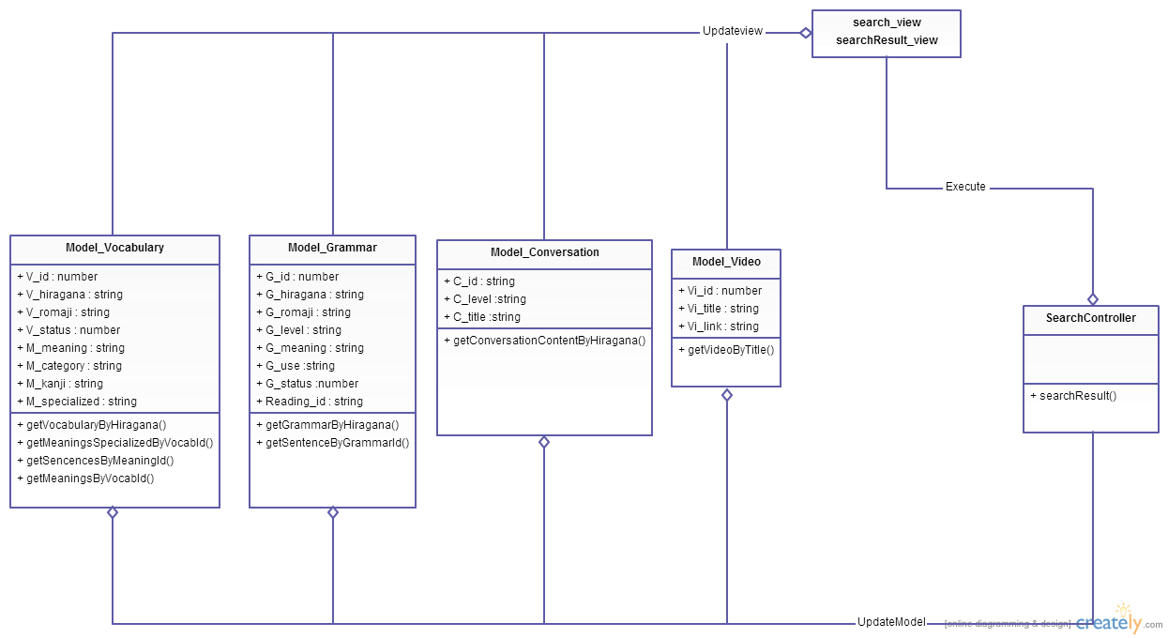

**Figure 1: Class diagram Admin package**

|  |  |  |
| --- | --- | --- |
| No | Class Name | Description |
| 1 | Model_Vocabulary |  |
| 2 | Model_Grammar |  |
| 3 | Model_Video |  |
| 4 | Model_Conversation |  |
| 5 | SearchController |  |

### Model_Vocabulary class

#### Attributes

|  |  |  |  |  |  |
| --- | --- | --- | --- | --- | --- |
| No | Attribute | Type | Default | Note | Description |
| 1. 1 | V_id | Int |  | private |  |
| 1. 2 | V_hiragana | String |  | private |  |
| 1. 3 | V_romaji | String |  | private |  |
| 1. 3 | V_status | Int |  | private |  |
|  | M_id | Int |  | private |  |
|  | M_meaningvn | String |  | private |  |
|  | M_category | String |  | private |  |
|  | M_kanji | String |  | private |  |
|  | M_specialized | String |  | private |  |

#### Methods

|  |  |  |
| --- | --- | --- |
| No | Method | Description |
|  | getVocabularyByHiragana() | Interact with database |
|  | getMeaningsSpecializedByVocabId() | Interact with database |
|  | getSencencesByMeaningId() | Interact with database |
|  | getMeaningsByVocabId() | Interact with database |

### Model_Grammar class

#### Attributes

|  |  |  |  |  |  |
| --- | --- | --- | --- | --- | --- |
| No | Attribute | Type | Default | Note | Description |
| 1. 1 | G_id | Int |  | private |  |
| 1. 2 | G_hiragana | String |  | private |  |
| 1. 3 | G_romaji | String |  | Private |  |
| 1. 3 | G_level | String |  | private |  |
|  | G_meaning | String |  | private |  |
|  | G_use | String |  | private |  |
|  | G_status | Int |  | Private |  |
|  | Reading_id | String |  | private |  |

#### Methods

|  |  |  |
| --- | --- | --- |
| No | Method | Description |
|  | getGrammarByHiragana() | Interact with database |
|  | getSentenceByGrammarId() | Interact with database |

### Model_Video class

#### Attributes

|  |  |  |  |  |  |
| --- | --- | --- | --- | --- | --- |
| No | Attribute | Type | Default | Note | Description |
| 1. 1 | Vi_id | Int |  | private |  |
| 1. 2 | Vi_title | String |  | private |  |
| 1. 3 | Vi_link | String |  | private |  |

#### Methods

|  |  |  |
| --- | --- | --- |
| No | Method | Description |
|  | getVideoByTitle() | Interact with database |

### Model_Conversation class

#### Attributes

|  |  |  |  |  |  |
| --- | --- | --- | --- | --- | --- |
| No | Attribute | Type | Default | Note | Description |
| 1. 1 | C_id | String |  | private |  |
| 1. 2 | C_level | String |  | private |  |
| 1. 3 | C_title | String |  | private |  |
|  | C_image | String |  | private |  |
|  | Con_id | Int |  | private |  |
|  | Con_title | String |  | private |  |
|  | Con_hiragana | String |  | private |  |
|  | Con_romaji | String |  | private |  |
|  | Con_meaning | String |  | private |  |

#### Methods

|  |  |  |
| --- | --- | --- |
| No | Method | Description |
|  | getConversationContentByHiragana() | Interact with database |

### SearchController

#### Attributes

|  |  |  |  |  |  |
| --- | --- | --- | --- | --- | --- |
| No | Attribute | Type | Default | Note | Description |
| 1 |  |  |  |  |  |

#### Methods

|  |  |  |
| --- | --- | --- |
| No | Method | Description |
|  | searchResults() | Display result search |

## Account management Package

### Class diagram

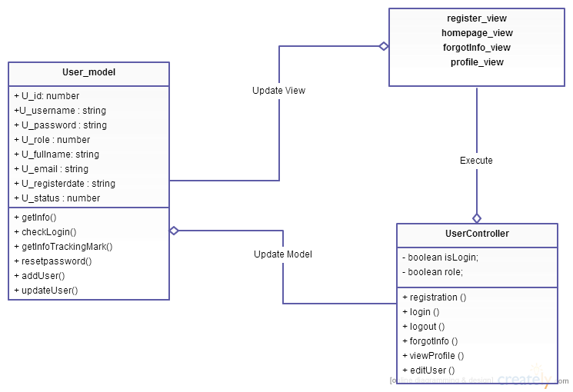

**Figure 2: Class diagram user package**

|  |  |  |
| --- | --- | --- |
| No | Class Name | Description |
| 1 | User_model |  |
| 2 | UserController |  |

### Model_User class

#### Attributes

|  |  |  |  |  |  |
| --- | --- | --- | --- | --- | --- |
| No | Attribute | Type | Default | Note | Description |
| 1 | u_id | Int |  | private |  |
| 2 | u_username | String |  | private |  |
| 3 | u_password | String |  | private |  |
| 4 | u_role | Int |  | private |  |
| 5 | u_fullname | String |  | private |  |
| 6 | u_email | String |  | private |  |
| 7 | u_registerdate | String |  | private |  |
| 8 | u_status | int |  | private |  |

#### Methods

|  |  |  |
| --- | --- | --- |
| No | Method | Description |
|  | addUser () | Interact with database |
|  | getInfo () | Interact with database |
|  | checkLogin() | Interact with database |
|  | Resetpassword() | Interact with database |
|  | updateUser() | Interact with database |

### UserController class

#### Attributes

|  |  |  |  |  |  |
| --- | --- | --- | --- | --- | --- |
| No | Attribute | Type | Default | Note | Description |
| 1 |  |  |  |  |  |

#### Methods

|  |  |  |
| --- | --- | --- |
| No | Method | Description |
|  | registration () | Register new account |
|  | Login() | Login to website |
|  | Logout() | Logout website |
|  | forgotInfo() | Reset password |
|  | viewProfile() | View Profile |
|  | editUser() | Edit account |

## Contact Package

### Class diagram

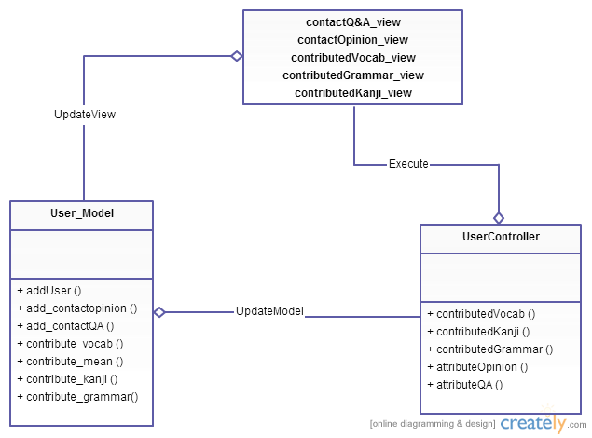

**Figure 3: Class diagram Contact package**

|  |  |  |
| --- | --- | --- |
| No | Class Name | Description |
| 1 | User_model |  |
| 2 | UserController |  |

### Model_User class

#### Attributes

#### Methods

|  |  |  |
| --- | --- | --- |
| No | Method | Description |
|  | add_contactopinion () | Interact with database |
|  | add_contactQA () | Interact with database |
|  | contribute_vocab () | Interact with database |
|  | contribute_mean () | Interact with database |
|  | contribute_kanji () | Interact with database |
|  | contribute_grammar() | Interact with database |

### UserController class

#### Attributes

|  |  |  |  |  |  |
| --- | --- | --- | --- | --- | --- |
| No | Attribute | Type | Default | Note | Description |
| 1 |  |  |  |  |  |

#### Methods

|  |  |  |
| --- | --- | --- |
| No | Method | Description |
|  | contributedVocab () | Contributed Vocabulary |
|  | contributedKanji () | Contributed Kanji |
|  | contributedGrammar () | Contributed Grammar |
|  | attributeOpinion () | Contributed Opinion |
|  | attributeQA () | Contributed QA |

## Practice management Package

### Class diagram

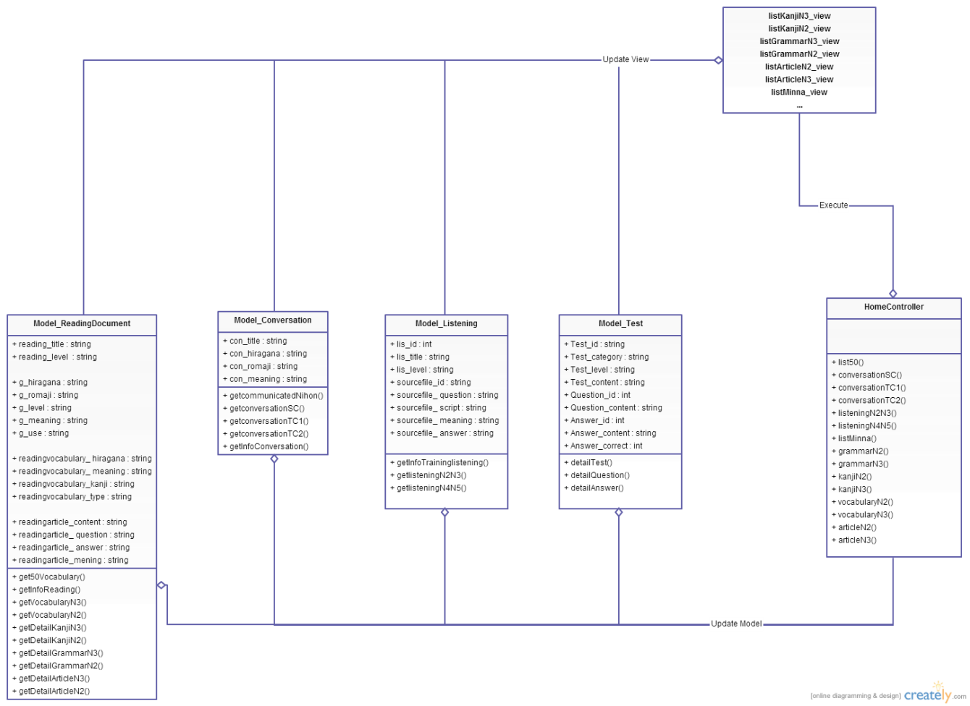

**Figure 4: Class diagram Practice management package**

|  |  |  |
| --- | --- | --- |
| No | Class Name | Description |
| 1 | Model_ReadingDocument |  |
| 2 | Model_Conversation |  |
| 3 | Model_Listening |  |
| 4 | Model_Test |  |
| 5 | ReadingDocumentController |  |

### Model ReadingDocument class

#### Attributes

|  |  |  |  |  |  |
| --- | --- | --- | --- | --- | --- |
| No | Attribute | Type | Default | Note | Description |
| 1. 1 | reading_title | String |  | private |  |
| 1. 2 | reading_level | String |  | private |  |
| 1. 3 | g_hiragana | String |  | private |  |
|  | g_romaji | String |  | private |  |
|  | g_level | String |  | private |  |
|  | g_meaning | String |  | private |  |
|  | g_use | String |  | private |  |
|  | readingvocabulary_ hiragana | String |  | private |  |
|  | readingvocabulary_ meaning | String |  | private |  |
|  | readingvocabulary_kanji | String |  | private |  |
|  | readingvocabulary_type | String |  | private |  |
|  | readingarticle_content | String |  | private |  |
|  | readingarticle_ question | String |  | private |  |
|  | readingarticle_ answer | String |  | private |  |
|  | readingarticle_mening | String |  | private |  |

#### Methods

|  |  |  |
| --- | --- | --- |
| No | Method | Description |
|  | get50Vocabulary() | Interact with database |
|  | getInfoReading() | Interact with database |
|  | getVocabularyN3() | Interact with database |
|  | getVocabularyN2() | Interact with database |
|  | getDetailKanjiN3() | Interact with database |
|  | getDetailKanjiN2() | Interact with database |
|  | getDetailGrammarN3() | Interact with database |
|  | getDetailGrammarN2() | Interact with database |
|  | getDetailArticleN3() | Interact with database |
|  | getDetailArticleN2() | Interact with database |

### Model Conversation class

#### Attributes

|  |  |  |  |  |  |
| --- | --- | --- | --- | --- | --- |
| No | Attribute | Type | Default | Note | Description |
| 1. 1 | C_id | String |  | private |  |
| 1. 2 | C_level | String |  | private |  |
| 1. 3 | C_title | String |  | private |  |
|  | C_image | String |  | private |  |
|  | Con_id | Int |  | private |  |
|  | Con_hiragana | String |  | private |  |
|  | Con_romaji | String |  | private |  |
|  | Con_meaning | String |  | private |  |
|  | Con_file | String |  | private |  |

#### Methods

|  |  |  |
| --- | --- | --- |
| No | Method | Description |
|  | getcommunicatedNihon() | Interact with database |
|  | getconversationSC() | Interact with database |
|  | getconversationTC1() | Interact with database |
|  | getconversationTC2() | Interact with database |
|  | getInfoConversation() | Interact with database |

### Model Listening class

#### Attributes

|  |  |  |  |  |  |
| --- | --- | --- | --- | --- | --- |
| No | Attribute | Type | Default | Note | Description |
| 1. 1 | Lis_id | Int |  | private |  |
| 1. 2 | Lis_title | String |  | private |  |
|  | Lis_level |  |  |  |  |
| 1. 3 | Sourcefile_id | String |  | Private |  |
| 1. 3 | Sourcefile_ question | String |  | private |  |
|  | Sourcefile_ script | String |  | private |  |
|  | Sourcefile_ meaning | String |  | private |  |

#### Methods

|  |  |  |
| --- | --- | --- |
| No | Method | Description |
|  | getInfoTraininglistening() | Interact with database |
|  | getlisteningN2N3() | Interact with database |
|  | getlisteningN4N5() | Interact with database |

### Model Test class

#### Attributes

|  |  |  |  |  |  |
| --- | --- | --- | --- | --- | --- |
| No | Attribute | Type | Default | Note | Description |
| 1. 1 | Test_id | String |  | private |  |
| 1. 2 | Test_category | String |  | private |  |
| 1. 3 | Test_level | String |  | private |  |
|  | Test_content | String |  | private |  |
|  | Question_id | String |  | private |  |
|  | Question_content | String |  | private |  |
|  | Answer_id | Int |  | private |  |
|  | Answer_content | String |  | private |  |
|  | Answer_correct | Int |  | private |  |

#### Methods

|  |  |  |
| --- | --- | --- |
| No | Method | Description |
| 1 | detailTest() | Interact with database |
| 2 | detailQuestion() | Interact with database |
| 3 | detailAnswer() | Interact with database |

### HomeController class

#### Attributes

|  |  |  |  |  |  |
| --- | --- | --- | --- | --- | --- |
| No | Attribute | Type | Default | Note | Description |
| 1 |  |  |  |  |  |

#### Methods

|  |  |  |
| --- | --- | --- |
| No | Method | Description |
|  | list50() | List 50 vocabulary of minanihon |
|  | conversationSC() | List Conversation level elementary |
|  | conversationTC1() | List Conversation level intermediate |
|  | conversationTC2() | List Conversation level intermediate |
|  | listeningN2N3() | List Listening level N2&N3 |
|  | listeningN4N5() | List Listening level N4&N5 |
|  | listMinna() | List minanihon |
|  | grammarN2() | List Grammar level N2 |
|  | grammarN3() | List Grammar level N3 |
|  | kanjiN2() | List Kanji level N2 |
|  | kanjiN3() | List Kanji level N3 |
|  | vocabularyN2() | List Vocabulary level N2 |
|  | vocabularyN3() | List Vocabulary level N3 |
|  | articleN2() | List Article level N2 |
|  | articleN3() | List Article level N3 |

## Admin’s account management Package

### Class diagram

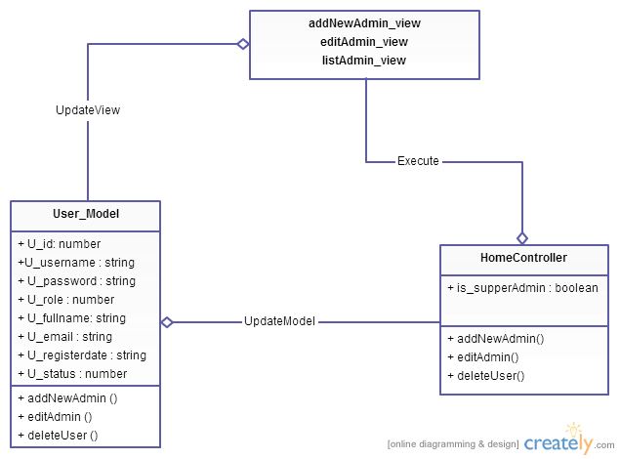

**Figure 5: Class diagram Admin’s account management package**

|  |  |  |
| --- | --- | --- |
| No | Class Name | Description |
| 1 | Model_User |  |
| 2 | HomeController |  |

### Model_User class

#### Attributes

|  |  |  |  |  |  |
| --- | --- | --- | --- | --- | --- |
| No | Attribute | Type | Default | Note | Description |
| 1 | u_id | Int |  | private |  |
| 2 | u_username | String |  | private |  |
| 3 | u_password | String |  | private |  |
| 4 | u_role | Int |  | private |  |
| 5 | u_fullname | String |  | private |  |
| 6 | u_email | String |  | private |  |
| 7 | u_registerdate | String |  | private |  |
| 8 | u_status | int |  | private |  |

#### Methods

|  |  |  |
| --- | --- | --- |
| No | Method | Description |
|  | addNewAdmin () | Interact with database |
|  | editAdmin () | Interact with database |
|  | deleteUser () | Interact with database |

### HomeController class

#### Attributes

|  |  |  |  |  |  |
| --- | --- | --- | --- | --- | --- |
| No | Attribute | Type | Default | Note | Description |
| 1 | Is_supperAdmin | boolean |  |  | Check role admin |

#### Methods

|  |  |  |
| --- | --- | --- |
| No | Method | Description |
|  | addNewAdmin() | Add a new account with role is admin |
|  | editAdmin() | Edit information |
|  | deleteUser() | Delete Admin |

## Management Member’s account

### Class diagram

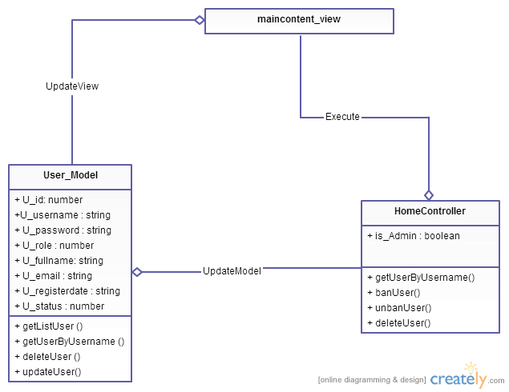

**Figure 6: Class diagram Management member package**

|  |  |  |
| --- | --- | --- |
| No | Class Name | Description |
| 1 | Model_User |  |
| 2 | HomeController |  |

### Model_User class

#### Attributes

|  |  |  |  |  |  |
| --- | --- | --- | --- | --- | --- |
| No | Attribute | Type | Default | Note | Description |
| 1 | u_id | Int |  | private |  |
| 2 | u_username | String |  | private |  |
| 3 | u_password | String |  | private |  |
| 4 | u_role | Int |  | private |  |
| 5 | u_fullname | String |  | private |  |
| 6 | u_email | String |  | private |  |
| 7 | u_registerdate | String |  | private |  |
| 8 | u_status | int |  | private |  |

#### Methods

|  |  |  |
| --- | --- | --- |
| No | Method | Description |
|  | getListUser () | Interact with database |
|  | getUserByUsername () | Interact with database |
|  | deleteUser () | Interact with database |
|  | updateUser() | Interact with database |

### HomeController class

#### Attributes

|  |  |  |  |  |  |
| --- | --- | --- | --- | --- | --- |
| No | Attribute | Type | Default | Note | Description |
| 1 | Is_Admin | boolean |  |  | Check role admin |

#### Methods

|  |  |  |
| --- | --- | --- |
| No | Method | Description |
|  | addNewAdmin() | Add a new account with role is admin |
|  | editAdmin() | Edit information |
|  | deleteUser() | Delete Admin |

## Vocabulary Management Package

### Class diagram

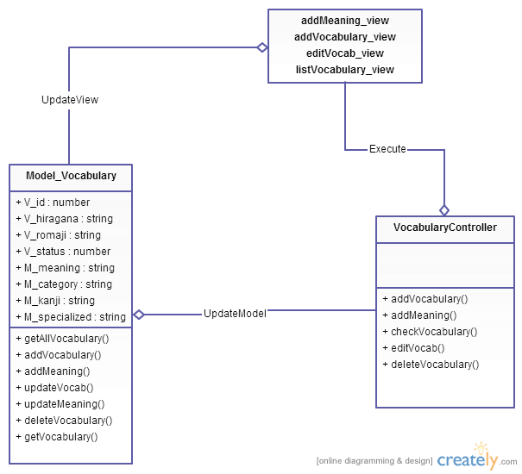

**Figure 7: Class diagram Vocabulary management package**

|  |  |  |
| --- | --- | --- |
| No | Class Name | Description |
| 1 | Model_Vocabulary |  |
| 2 | VocabularyController |  |

### Model_Vocabulary class

#### Attributes

|  |  |  |  |  |  |
| --- | --- | --- | --- | --- | --- |
| No | Attribute | Type | Default | Note | Description |
| 1 | V_id | Int |  | private |  |
| 2 | V_hiragana | String |  | private |  |
| 3 | V_romaji | String |  | private |  |
| 5 | V_status | Int |  | private |  |
| 6 | M_id | Int |  | private |  |
| 7 | M_meaningvn | String |  | private |  |
| 8 | M_category | String |  | private |  |
| 9 | M_kanji | String |  | private |  |
| 10 | M_specialized | String |  | private |  |

#### Methods

|  |  |  |
| --- | --- | --- |
| No | Method | Description |
| 1 | getAllVocabulary() | Interact with database |
| 2 | addVocabulary() | Interact with database |
| 3 | addMeaning() | Interact with database |
| 4 | updateVocab() | Interact with database |
| 5 | updateMeaning() | Interact with database |
| 6 | deleteVocabulary() | Interact with database |
| 7 | getVocabulary() | Interact with database |

### VocabularyController class

#### Attributes

|  |  |  |  |  |  |
| --- | --- | --- | --- | --- | --- |
| No | Attribute | Type | Default | Note | Description |
|  |  |  |  |  |  |

#### Methods

|  |  |  |
| --- | --- | --- |
| No | Method | Description |
|  | addVocabulary() | Create vocabulary |
|  | addMeaning() | Add meaning of vocabulary |
|  | checkVocabulary() | Check exits vocabulary |
|  | editVocab() | Edit vocabulary |
|  | deleteVocabulary() | Delete Vocabulary |

## Grammar Management Package

### Class diagram

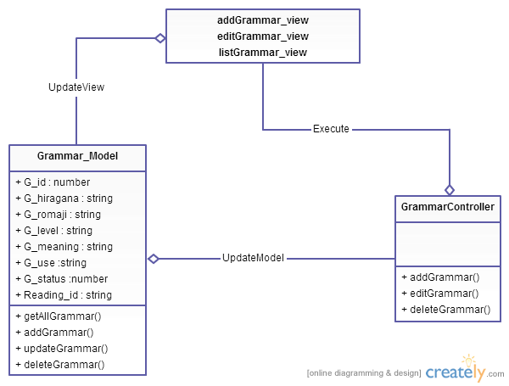

**Figure 8: Class diagram Grammar management package**

|  |  |  |
| --- | --- | --- |
| No | Class Name | Description |
| 1 | Model_Grammar |  |
| 2 | GrammarController |  |

### Model_Grammar class

#### Attributes

|  |  |  |  |  |  |
| --- | --- | --- | --- | --- | --- |
| No | Attribute | Type | Default | Note | Description |
| 1. 1 | G_id | Int |  | private |  |
| 1. 2 | G_hiragana | String |  | private |  |
| 1. 3 | G_romaji | String |  | Private |  |
| 1. 3 | G_level | String |  | private |  |
|  | G_meaning | String |  | private |  |
|  | G_use | String |  | private |  |
|  | G_status | Int |  | Private |  |
|  | Reading_id | String |  | private |  |

#### Methods

|  |  |  |
| --- | --- | --- |
| No | Method | Description |
|  | getAllGrammar() | Interact with database |
|  | addGrammar() | Interact with database |
|  | updateGrammar() | Interact with database |
|  | deleteGrammar() | Interact with database |

### GrammarController class

#### Attributes

|  |  |  |  |  |  |
| --- | --- | --- | --- | --- | --- |
| No | Attribute | Type | Default | Note | Description |
|  |  |  |  |  |  |

#### Methods

|  |  |  |
| --- | --- | --- |
| No | Method | Description |
|  | addGrammar() | Create grammar |
|  | editGrammar() | Edit grammar |
|  | deleteGrammar() | Delete grammar |
|  | Index() | List grammar |

## Kanji Management Package

### Class diagram

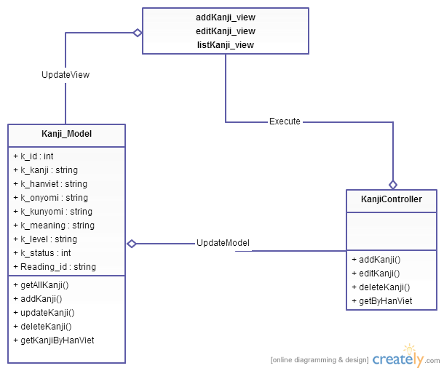

**Figure 9: Class diagram Kanji management package**

|  |  |  |
| --- | --- | --- |
| No | Class Name | Description |
| 1 | Model_Kanji |  |
| 2 | KanjiController |  |

### Model_Kanji class

#### Attributes

|  |  |  |  |  |  |
| --- | --- | --- | --- | --- | --- |
| No | Attribute | Type | Default | Note | Description |
| 1. 1 | K_id | Int |  | private |  |
| 1. 2 | K_kanji | String |  | private |  |
| 1. 3 | K_hanviet | String |  | Private |  |
| 1. 3 | K_onyomi | String |  | private |  |
|  | K_kunyomi | String |  | private |  |
|  | K_meaning | String |  | private |  |
|  | K_level | String |  | private |  |
|  | K_status | Int |  | private |  |
|  | Reading_id | String |  | private |  |

#### Methods

|  |  |  |
| --- | --- | --- |
| No | Method | Description |
|  | getAllKanji() | Interact with database |
|  | addKanji() | Interact with database |
|  | updateKanji() | Interact with database |
|  | deleteKanji() | Interact with database |
|  | getKanjiByHanViet() | Interact with database |

### KanjiController class

|  |  |  |  |  |  |
| --- | --- | --- | --- | --- | --- |
|  |  |  |  |  |  |

#### Attributes

|  |  |  |  |  |  |
| --- | --- | --- | --- | --- | --- |
| No | Attribute | Type | Default | Note | Description |
|  |  |  |  |  |  |

#### Methods

|  |  |  |
| --- | --- | --- |
| No | Method | Description |
|  | addKanji() | Create kanji |
|  | editKanji() | Edit kanji |
|  | deleteKanji() | Delete kanji |
|  | Get\ByHanViet() | Search kanji |

## ReadingDocument Management Package

### Class diagram

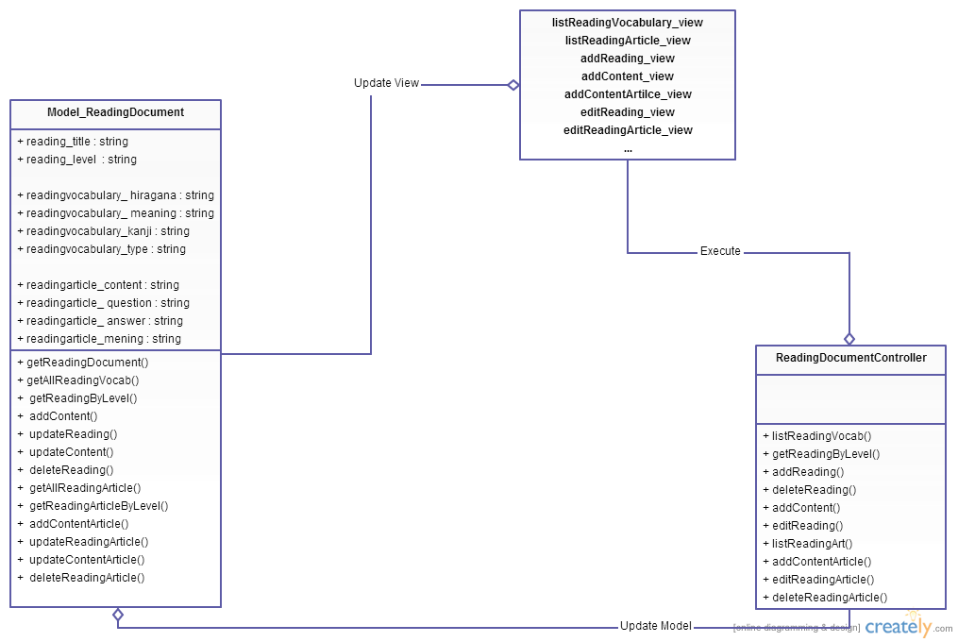

**Figure 10: Class diagram ReadingDocument management package**

|  |  |  |
| --- | --- | --- |
| No | Class Name | Description |
| 1 | Model_ReadingDocument |  |
| 2 | ReadingDocumentController |  |

### Model ReadingDocument class

#### Attributes

|  |  |  |  |  |  |
| --- | --- | --- | --- | --- | --- |
| No | Attribute | Type | Default | Note | Description |
| 1 | reading_title | String |  | private |  |
| 2 | reading_level | String |  | private |  |
| 3 | readingvocabulary_ hiragana | String |  | private |  |
| 4 | readingvocabulary_ meaning | String |  | private |  |
| 5 | readingvocabulary_kanji | String |  | private |  |
| 6 | readingvocabulary_type | String |  | private |  |
| 7 | readingarticle_content | String |  | private |  |
| 8 | readingarticle_ question | String |  | private |  |
| 9 | readingarticle_ answer | String |  | private |  |
| 10 | readingarticle_mening | String |  | private |  |

#### Methods

|  |  |  |
| --- | --- | --- |
| No | Method | Description |
| 1 | getReadingDocument() | Interact with database |
| 2 | getAllReadingVocab() | Interact with database |
| 3 | getReadingByLevel() | Interact with database |
| 4 | addContent() | Interact with database |
| 5 | updateReading() | Interact with database |
| 6 | updateContent() | Interact with database |
| 7 | deleteReading() | Interact with database |
| 8 | getAllReadingArticle() | Interact with database |
| 9 | getReadingArticleByLevel() | Interact with database |
| 10 | addContentArticle() | Interact with database |
| 11 | updateReadingArticle() | Interact with database |
| 12 | updateContentArticle() | Interact with database |
| 13 | deleteReadingArticle() | Interact with database |

### ReadingDocumentController class

#### Attributes

|  |  |  |  |  |  |
| --- | --- | --- | --- | --- | --- |
| No | Attribute | Type | Default | Note | Description |
| 1 |  |  |  |  |  |

#### Methods

|  |  |  |
| --- | --- | --- |
| No | Method | Description |
|  | listReadingVocab() | List vocabulary of readingdocument |
|  | getReadingByLevel() | Search reading document |
|  | addReading() | Add Reading document |
|  | deleteReading() | Delete Reading document |
|  | addContent() | Add vocabulary of reading document |
|  | editReading() | Edit Reading document |
|  | listReadingArt() | List Article |
|  | addContentArticle() | Add content of Article |
|  | editReadingArticle() | Edit Article |
|  | deleteReadingArticle() | Delete Article |

## Conversation Management Package

### Class diagram

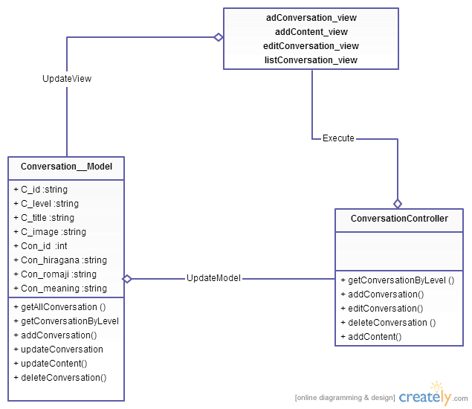

**Figure 11: Class diagram Conversation package**

|  |  |  |
| --- | --- | --- |
| No | Class Name | Description |
| 1 | Model_Conversation |  |
| 2 | Conversation Controller |  |

### Model_Conversation class

#### Attributes

|  |  |  |  |  |  |
| --- | --- | --- | --- | --- | --- |
| No | Attribute | Type | Default | Note | Description |
| 1. 1 | C_id | String |  | private |  |
| 1. 2 | C_level | String |  | private |  |
| 1. 3 | C_title | String |  | private |  |
|  | C_image | String |  | private |  |
|  | Con_id | Int |  | private |  |
|  | Con_hiragana | String |  | private |  |
|  | Con_romaji | String |  | private |  |
|  | Con_meaning | String |  | private |  |
|  | Con_file | String |  | private |  |

#### Methods

|  |  |  |
| --- | --- | --- |
| No | Method | Description |
|  | getAllConversation () | Interact with database |
|  | getConversationByLevel() | Interact with database |
|  | addConversation() | Interact with database |
|  | updateConversation() | Interact with database |
|  | updateContent() | Interact with database |
|  | deleteConversation() | Interact with database |

### ConversationController

#### Attributes

|  |  |  |  |  |  |
| --- | --- | --- | --- | --- | --- |
| No | Attribute | Type | Default | Note | Description |
|  |  |  |  |  |  |

#### Methods

|  |  |  |
| --- | --- | --- |
| No | Method | Description |
|  | getConversationByLevel () | Search Conversation |
|  | addConversation() | Add Conversation |
|  | editConversation() | Edit Conversation |
|  | deleteConversation () | Delete Conversation |
|  | addContent() | Add Content of Conversation |

## Video Package

### Class diagram

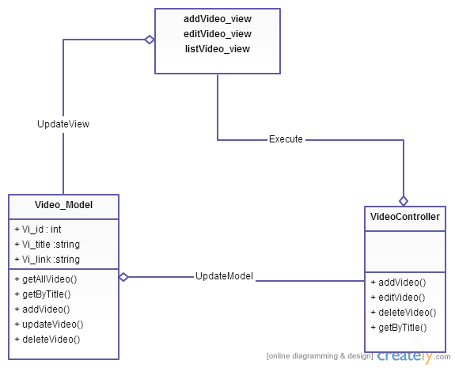

**Figure 12: Class diagram Video package**

|  |  |  |
| --- | --- | --- |
| No | Class Name | Description |
| 1 | Model_Video |  |
| 2 | VideoController |  |

### Model_Video class

#### Attributes

|  |  |  |  |  |  |
| --- | --- | --- | --- | --- | --- |
| No | Attribute | Type | Default | Note | Description |
| 1. 1 | Vi_id | Int |  | private |  |
| 1. 2 | Vi_title | String |  | private |  |
| 1. 3 | Vi_link | String |  | Private |  |

#### Methods

|  |  |  |
| --- | --- | --- |
| No | Method | Description |
|  | getAllVideo() | Interact with database |
|  | getByTitle() | Interact with database |
|  | addVideo() | Interact with database |
|  | updateVideo() | Interact with database |
|  | deleteVideo() | Interact with database |

### VideoController

#### Attributes

|  |  |  |  |  |  |
| --- | --- | --- | --- | --- | --- |
| No | Attribute | Type | Default | Note | Description |
|  |  |  |  |  |  |

#### Methods

|  |  |  |
| --- | --- | --- |
| No | Method | Description |
|  | addVideo() | Create Video |
|  | editVideo() | Edit Video |
|  | deleteVideo() | Delete Video |
|  | getByTitle() | Search Video |

## TrainingListening Package

### Class diagram

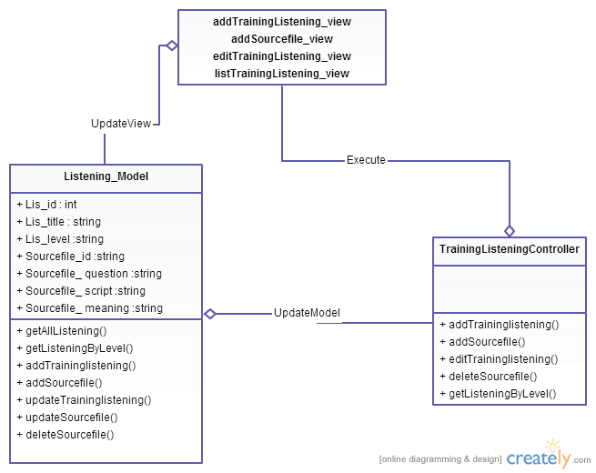

**Figure 13: Class diagram TrainingListening package**

|  |  |  |
| --- | --- | --- |
| No | Class Name | Description |
| 1 | Model_TrainingListening |  |
| 2 | TrainingListening Controller |  |

### Model_TraniningListening class

#### Attributes

|  |  |  |  |  |  |
| --- | --- | --- | --- | --- | --- |
| No | Attribute | Type | Default | Note | Description |
| 1. 1 | Lis_id | Int |  | private |  |
| 1. 2 | Lis_title | String |  | private |  |
|  | Lis_level |  |  |  |  |
| 1. 3 | Sourcefile_id | String |  | Private |  |
| 1. 3 | Sourcefile_ question | String |  | private |  |
|  | Sourcefile_ script | String |  | private |  |
|  | Sourcefile_ meaning | String |  | private |  |

#### Methods

|  |  |  |
| --- | --- | --- |
| No | Method | Description |
|  | getAllListening() | Interact with database |
|  | getListeningByLevel() | Interact with database |
|  | addTraininglistening() | Interact with database |
|  | addSourcefile() | Interact with database |
|  | updateTraininglistening() | Interact with database |
|  | updateSourcefile() | Interact with database |
|  | deleteSourcefile() | Interact with database |

### TrainingListeningController

#### Attributes

|  |  |  |  |  |  |
| --- | --- | --- | --- | --- | --- |
| No | Attribute | Type | Default | Note | Description |
|  |  |  |  |  |  |

#### Methods

|  |  |  |
| --- | --- | --- |
| No | Method | Description |
|  | addTraininglistening() | Create Training Listening |
|  | addSourcefile() | Add Source file |
|  | editTraininglistening() | Edit Training Listening |
|  | deleteSourcefile() | Delete Training Listening |
|  | getListeningByLevel() | Search Training Listening |

## Test Management Package

### Class diagram

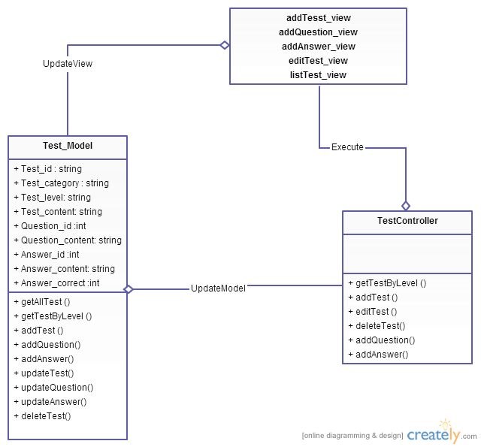

**Figure 14: Class diagram Test package**

|  |  |  |
| --- | --- | --- |
| No | Class Name | Description |
| 1 | Model_Test |  |
| 2 | Test Controller |  |

### Model_Test class

#### Attributes

|  |  |  |  |  |  |
| --- | --- | --- | --- | --- | --- |
| No | Attribute | Type | Default | Note | Description |
| 1. 1 | Test_id | String |  | private |  |
| 1. 2 | Test_category | String |  | private |  |
| 1. 3 | Test_level | String |  | private |  |
|  | Test_content | String |  | private |  |
|  | Question_id | String |  | private |  |
|  | Question_content | String |  | private |  |
|  | Answer_id | Int |  | private |  |
|  | Answer_content | String |  | private |  |
|  | Answer_correct | Int |  | private |  |

#### Methods

|  |  |  |
| --- | --- | --- |
| No | Method | Description |
| 1 | getAllTest () | Interact with database |
| 2 | getTestByLevel () | Interact with database |
| 3 | addTest () | Interact with database |
| 4 | addQuestion() | Interact with database |
| 5 | addAnswer() | Interact with database |
| 6 | updateTest() | Interact with database |
| 7 | updateQuestion() | Interact with database |
| 8 | updateAnswer() | Interact with database |
| 9 | deleteTest() | Interact with database |

### TestController

#### Attributes

|  |  |  |  |  |  |
| --- | --- | --- | --- | --- | --- |
| No | Attribute | Type | Default | Note | Description |
|  |  |  |  |  |  |

#### Methods

|  |  |  |
| --- | --- | --- |
| No | Method | Description |
| 1 | getTestByLevel () | Search Test |
| 2 | addTest () | Create Test |
| 3 | editTest () | Edit Test |
| 4 | deleteTest() | Delete Test |
| 5 | addQuestion() | Add Question of Test |
| 6 | addAnswer() | Add Answer of Question |

## Contact management Package

### Class diagram

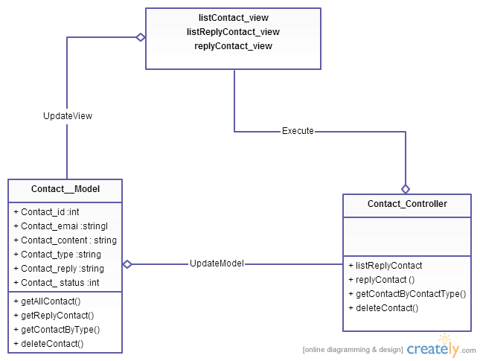

**Figure 15: Class diagram Contact package**

|  |  |  |
| --- | --- | --- |
| No | Class Name | Description |
| 1 | Model_Contact |  |
| 2 | ContactController |  |

### Model_Contact class

#### Attributes

|  |  |  |  |  |  |
| --- | --- | --- | --- | --- | --- |
| No | Attribute | Type | Default | Note | Description |
| 1. 1 | Contact_id | Int |  | private |  |
| 1. 2 | Contact_email | String |  | private |  |
| 1. 3 | Contact_content | String |  | private |  |
|  | Contact_type | String |  | private |  |
|  | Contact_reply | String |  | Private |  |
|  | Contact_ status | Int |  | Private |  |

#### Methods

|  |  |  |
| --- | --- | --- |
| No | Method | Description |
|  | getAllContact() | Interact with database |
|  | getReplyContact() | Interact with database |
|  | getContactByType() | Interact with database |
|  | deleteContact() | Interact with database |

### ContactController

#### Attributes

|  |  |  |  |  |  |
| --- | --- | --- | --- | --- | --- |
| No | Attribute | Type | Default | Note | Description |
|  |  |  |  |  |  |

#### Methods

|  |  |  |
| --- | --- | --- |
| No | Method | Description |
|  | listReplyContact | List Contact |
|  | replyContact () | Reply Contact |
|  | getContactByContactType() | Search Contact |
|  | deleteContact() | Delete Contact |

# MVC model

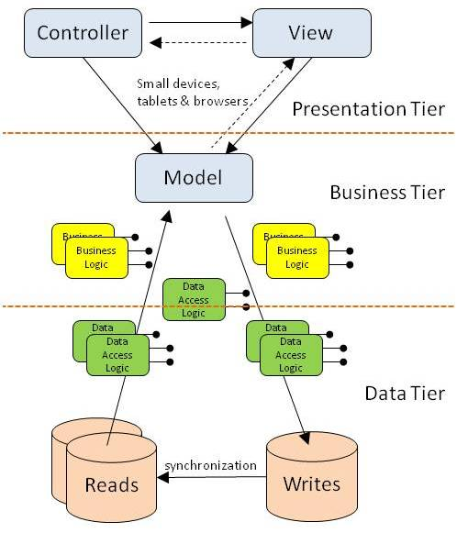

***Figure 6: MVC Model***